Product Review and Rating Management System

Project Title: E-Commerce Order Management Database System

Project Title : E-Commerce Order Management Database System
Student Name :Yoga moorthy S
Register Number : C4S38025
Department : B.Sc Artificial Intelligence
Course : Artificial intelligence (AI)
Academic Year : 2024 – 2027

. Create Review and Rating Tables
CREATE DATABASE ProductReviewDB;
USE ProductReviewDB;

CREATE TABLE Review (
Review_ID INT PRIMARY KEY AUTO_INCREMENT,
Product_ID INT NOT NULL,
Customer_ID INT NOT NULL,
Review_Text VARCHAR(500),
Review_Date DATE
);

CREATE TABLE Rating (
Rating_ID INT PRIMARY KEY AUTO_INCREMENT,
Review_ID INT NOT NULL,
Rating_Value DECIMAL(2,1),
FOREIGN KEY (Review_ID) REFERENCES Review(Review_ID)
);

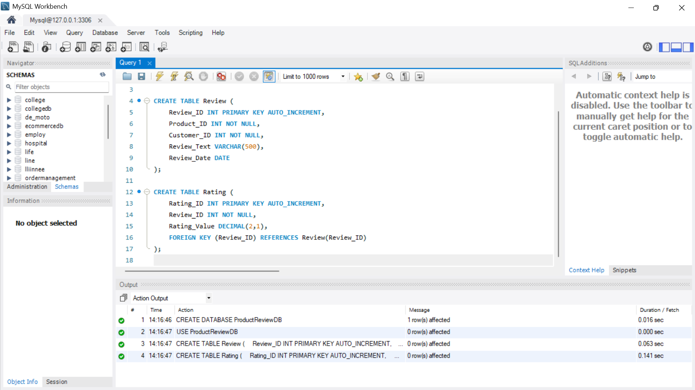
2. Insert Customer Feedback and Ratings
INSERT INTO Review
(Product_ID, Customer_ID, Review_Text, Review_Date)
VALUES
(101, 1, 'Good quality product', '2026-08-10'),
(101, 2, 'Very useful and worth the price', '2026-08-11'),
(102, 3, 'Average product', '2026-08-12'),
(103, 4, 'Excellent product', '2026-08-13'),
(103, 5, 'Very satisfied with the product', '2026-08-14');
Insert the ratings:
INSERT INTO Rating
(Review_ID, Rating_Value)
VALUES
(1, 4.0),
(2, 5.0),
(3, 3.0),
(4, 5.0),
(5, 4.5);
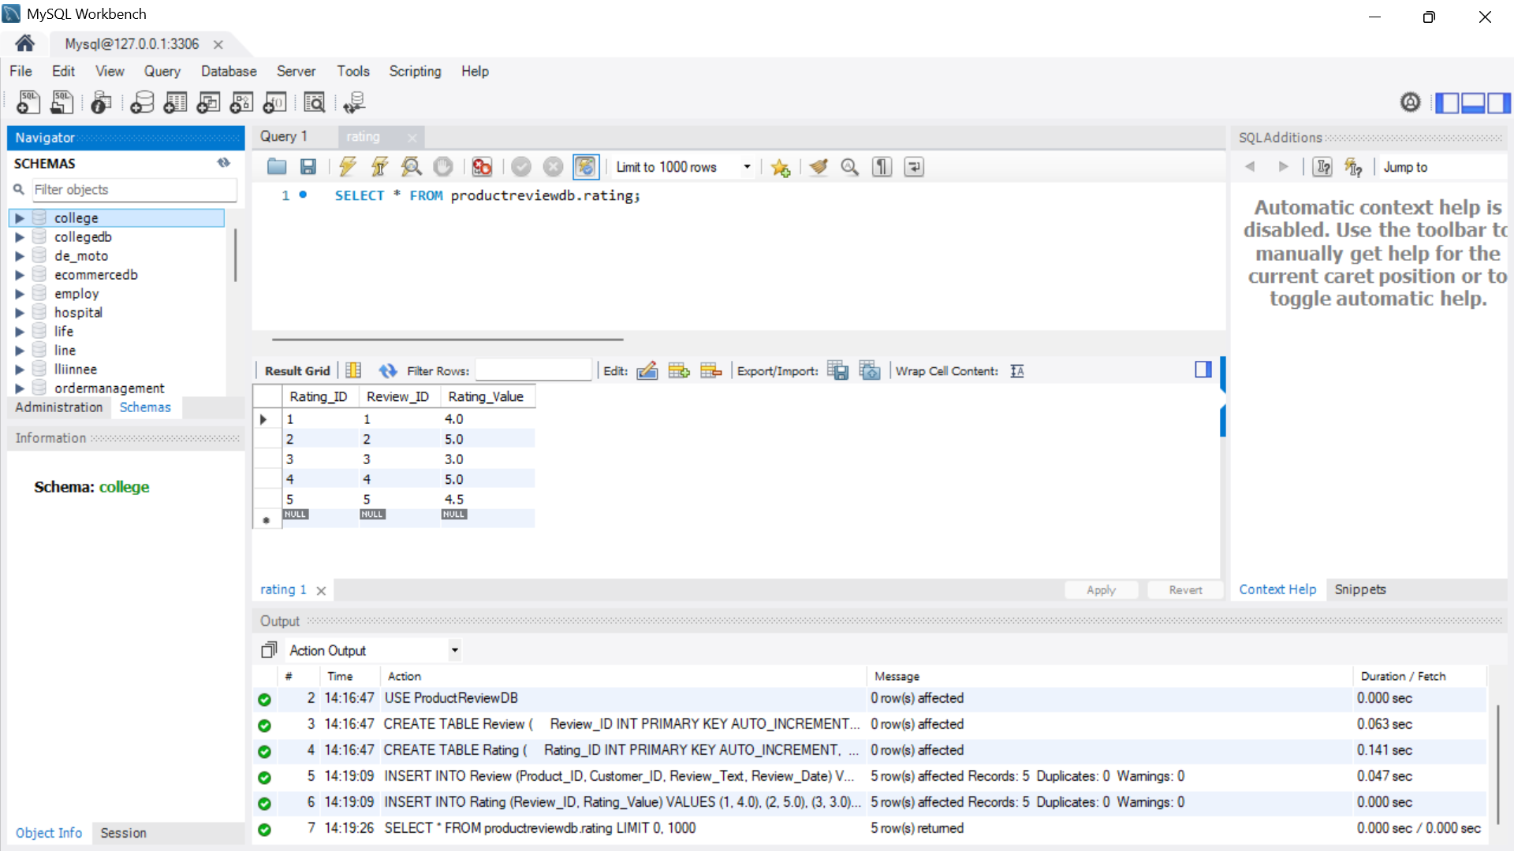
3. Retrieve Product Review Details
To display the product, customer, review, and rating:
SELECT
r.Product_ID,
r.Customer_ID,
r.Review_Text,
r.Review_Date,
rt.Rating_Value
FROM Review r
JOIN Rating rt
ON r.Review_ID = rt.Review_ID;
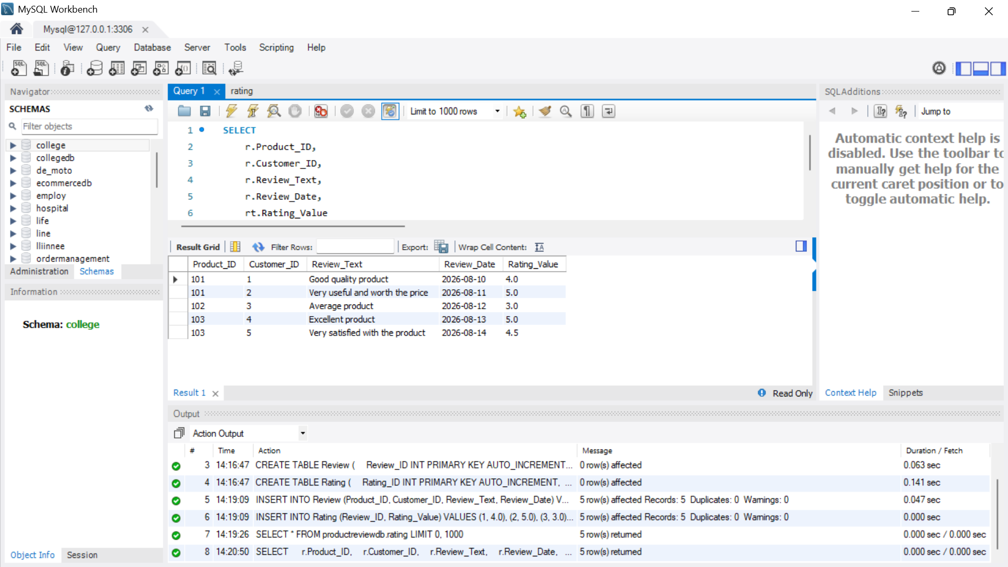
4. Calculate Average Product Ratings
Use the AVG() aggregate function:
SELECT
r.Product_ID,
AVG(rt.Rating_Value) AS Average_Rating
FROM Review r
JOIN Rating rt
ON r.Review_ID = rt.Review_ID
GROUP BY r.Product_ID;
Example result:
Product ID | Average Rating
101 | 4.50
102 | 3.00
103 | 4.75
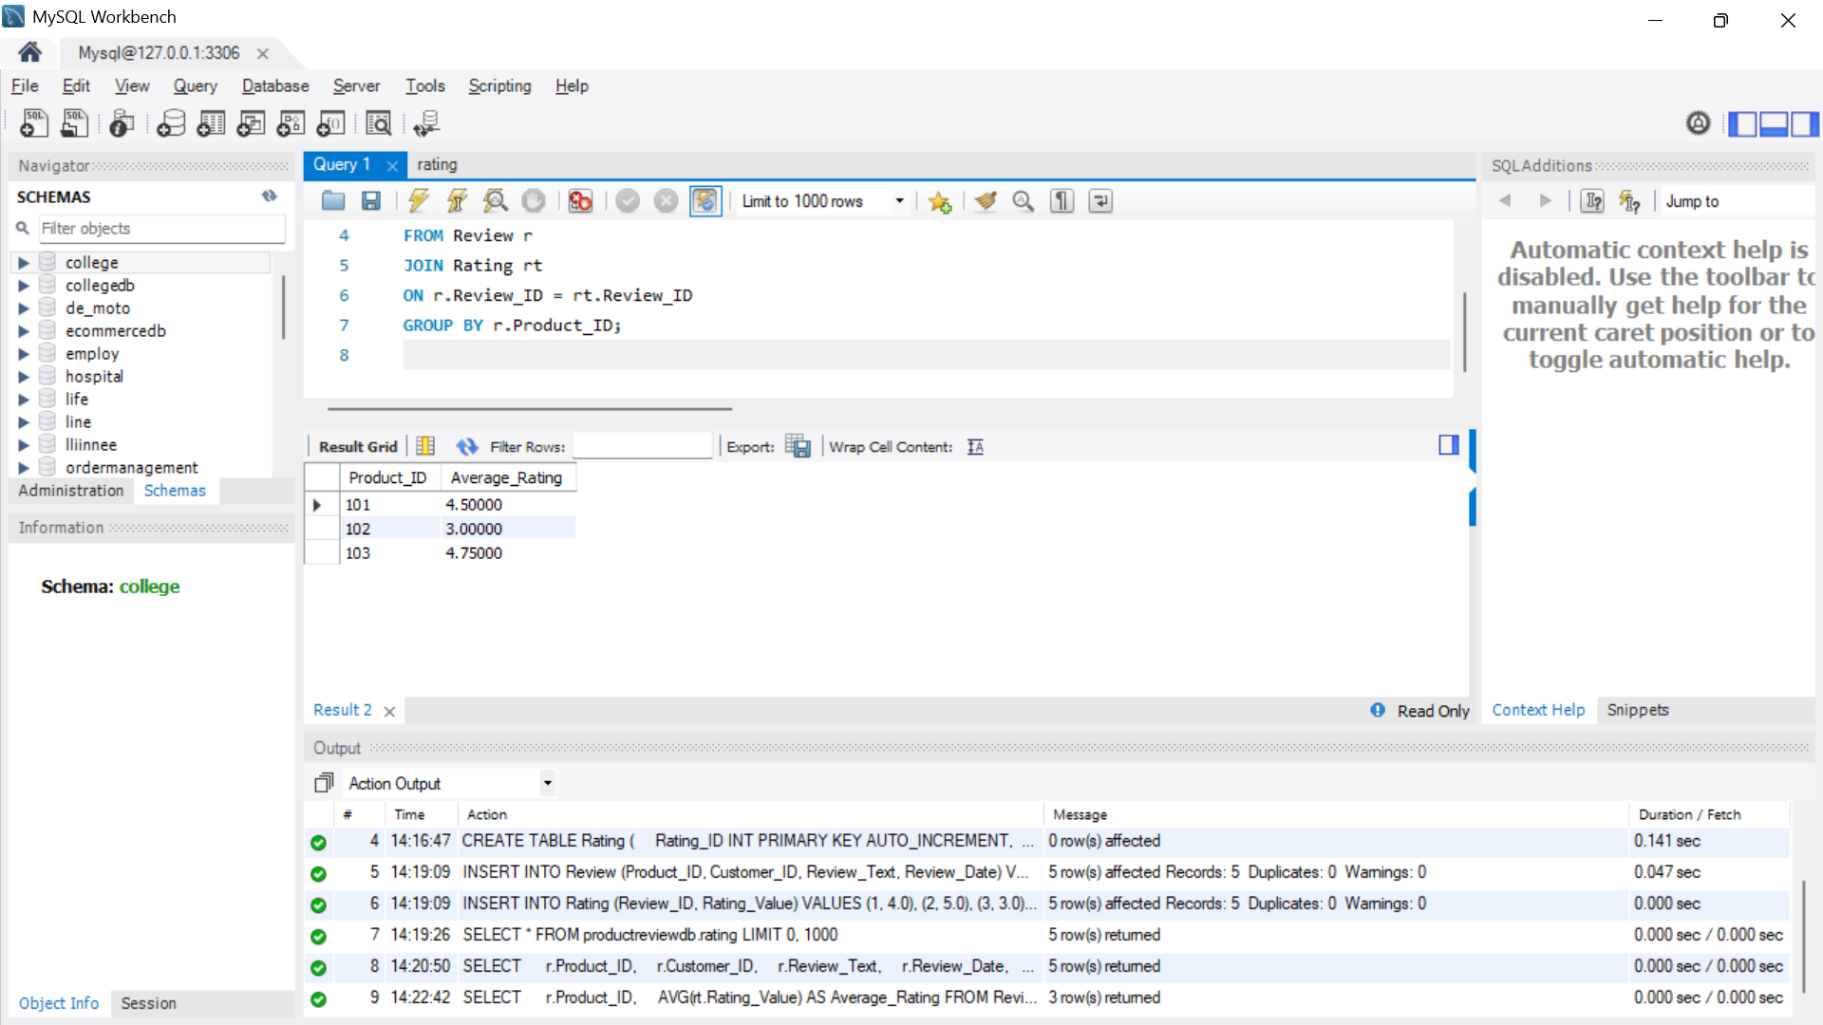
5. Identify Highly Rated Products
For example, products having an average rating of 4 or above:
SELECT
r.Product_ID,
AVG(rt.Rating_Value) AS Average_Rating
FROM Review r
JOIN Rating rt
ON r.Review_ID = rt.Review_ID
GROUP BY r.Product_ID
HAVING AVG(rt.Rating_Value) >= 4.0;
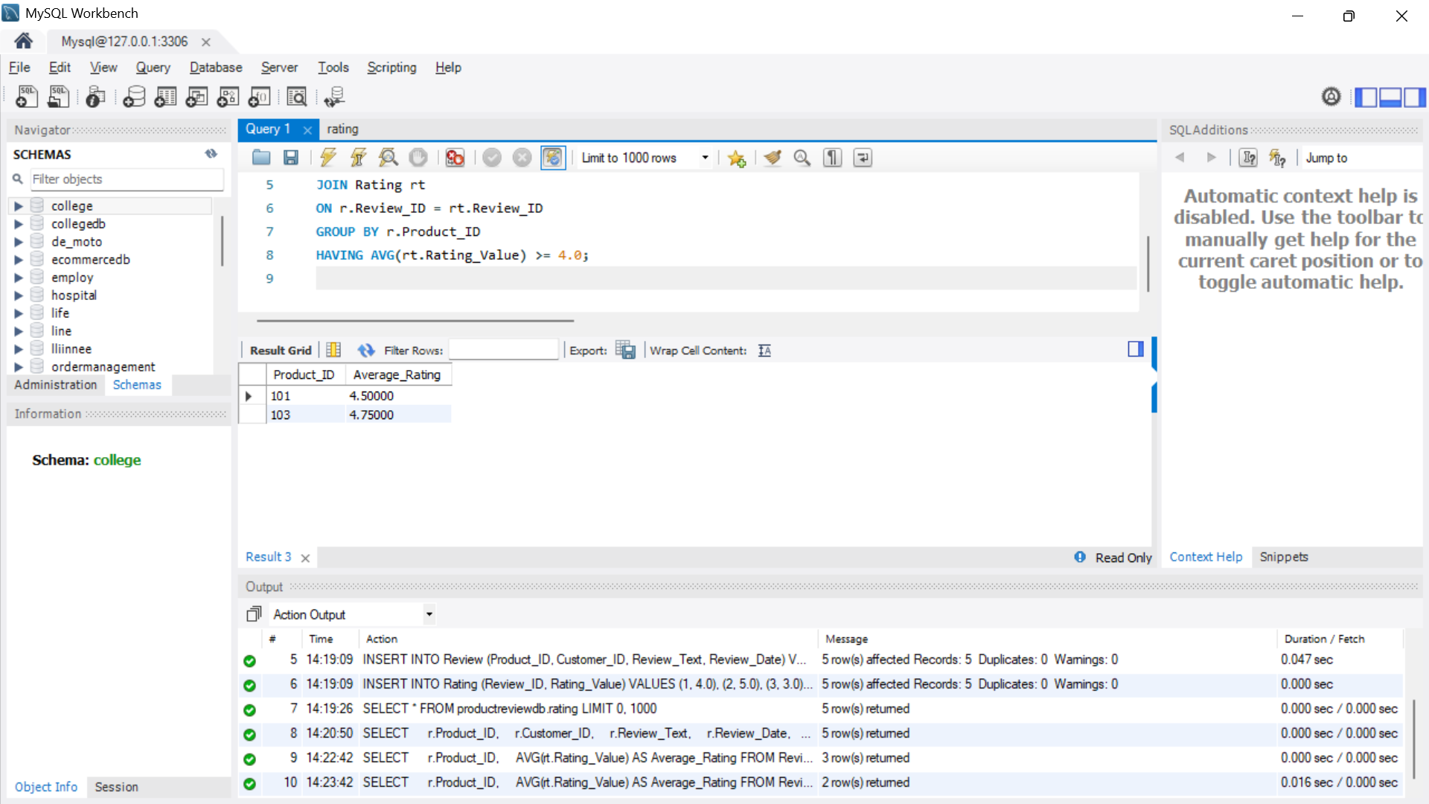
Useful Aggregate Functions
- AVG() → calculates average rating
- COUNT() → counts number of reviews
- MAX() → finds highest rating
- MIN() → finds lowest rating
For example, to find the number of reviews for each product:
SELECT
Product_ID,
COUNT(*) AS Total_Reviews
FROM Review
GROUP BY Product_ID;
